Chapter 4
A Deep CNN Framework for Automated Mushroom Disease Classification
Mushroom cultivation significantly contributes to economic growth owing to its abundant medicinal properties. However, it is prone to diseases that eventually affect the quality and quantity of the mushroom yield adversely. The accurate detection of mushroom diseases thus plays a major role in ensuring food security and reducing economic losses. In this study, the authors present a Deep Learning-based framework for efficient classification of diseased and healthy edible mushrooms, with the help of three pre-trained Convolutional Neural Network architectures, namely, DenseNet201, VGG16, and VGG19. The custom dataset of 5,142 images was curated using 5000 healthy mushroom images from an open-source database and 142 diseased mushroom images. This dataset was evaluated under two scenarios of train-test splits (80:20 and 70:30), under two cases, i.e., without augmentation and with augmentation. In case 1 of the non-augmented dataset, DenseNet201 performed the best in both scenarios of splits, i.e., 99.81% and 99.74% accuracies for 80:20 and 70:30 splits, respectively, with a precision, recall, and F1-score of 100%, 94%, and 97% in the 80:20 split scenario. In case 2, the 142 diseased mushroom images were augmented using rotation, flipping, zooming, cropping, width shifting, and brightness adjustment techniques to become 2080 images, the total being 7080 images, i.e., 5000 healthy and 2080 diseased. The performance improved significantly with augmentation, where the DenseNet201 performed the best, achieving 99.79% and 99.76% accuracies in cases of 80:20 and 70:30 split scenarios, respectively. The precision, recall, and F1-score reached ~ 100%. Training and validation analyses over 10 epochs produced faster convergence with a lower validation loss of <0.01, and enhanced generalization for DenseNet201. Overall, DenseNet201 emerged as the most robust and reliable architecture for mushroom disease detection, offering strong potential for real-time agriculture applications and enhancing sustainability.

Introduction
The study’s main contributions are as follows:
- A related literature review is provided to categorize various mushroom types and their diseases using Machine Learning (ML) and Deep learning (DL) techniques.
- A framework is suggested to categorize edible mushrooms into healthy and diseased.
- A dataset of 500 healthy mushroom images is developed using free online databases, and a dataset of 142 diseased images is collected physically from a mushroom-cultivated farm.
- A comprehensive evaluation and comparison of three DL pretrained models, VGG16, VGG19, and Desnet201, for the classification of healthy and diseased mushrooms using a dataset of 5142 images.
- Researchers select the optimal DL architecture by comparing three state-of-the-art CNN architectures for the classification of mushroom diseases.
The rest of the manuscript is structured as follows: Section 2 addresses various mushroom species and their diseases. Section 3 presents a detailed review of existing literature related to ML and DL approaches used for mushroom disease detection and mushroom species classification. Section 4 describes the methodology used in the manuscript. Section 5 discusses the proposed framework of mushroom species classification and provides the experimental setup, performance metrics, and comparative analysis of results obtained using various models. Section 6 summarizes the paper and outlines future research directions in mushroom disease detection using DL-based techniques.

Related Work
Numerous researchers have worked in the field of mushroom type classification, mushroom disease classification using s transformed the process of identifying a disease in crops such as apples, tomatoes, and wheat [24] by making it possible to intervene at an early stage by classifying the disease with high accuracy with respect to slight differences in visual appearance. CNNs are highly suited to identify small differences between healthy and infected samples [25] and classify various diseases of mushrooms because of their capability to extract complex patterns of images.

  - Deep learning techniques for mushroom disease classification and species classification
Deep learning techniques help to work faster on images as compared to ML methods.ML methods, which work faster in cases of categorical or numerical data. Albayrak et al used a dataset of 3,195 images, where 2,464 were images of infected mushrooms, and 731 were images of healthy ones, all recorded under uniform white-light lighting. These samples were classified using 20 complex CNN architecture. Reliability of the models is enhanced by two white line model. Performance evaluation was done based on a weighted score including F1-score, precision, AUC, and recall. ResNet-50 scored the maximum accuracy of 99.70%, outperforming DarkNet-53 and DenseNet-201 [25]. In another study, an enhanced “ConvNeXt V2” model is proposed for mushroom categorization whereby, cross-modular feature fusion and data augmentation for better accuracy [26].
The study [27] focused on eight architectures: This work makes use of numerous pre-trained CNN models including CNN-features, ResNet 50, VGG16, Inception V3, DenseNet 121, EfficientNet, MobileNet v2, and Xception. In this work, these models have been assessed on a database containing images of mushrooms in respect of “F1-score”, “precision”, “accuracy”, and “recall”. The research reveals that even though certain architectures as EfficientNet and DenseNet 121 have a higher accuracy rate and performance in general, some work better in particular for some tasks, such as faster speed of generating results or lower usage of computations. Another study [28] validated a detection device for the speedy diagnosis of fungal diseases. This system includes (1) high accuracy environmental controlling, (b) a new imaging robot system; and (c) the deep learning fungus disease early diagnosis system with the alarm, and the diagnosis result. Real-time disease prognosis system of the current work has an accuracy of 94.35% with F1 score of 89.47 % with n=13,500 and is controlled twice daily with an average time of 6-12 hours for detecting and reporting fungal diseases. Evaluation of Innovation Farm’s passive technology capabilities in mushroom cultivation (environmental control). The precision of the control (variation within 3 months) was 99.6% thus rating the mushrooms' environmental control as excellent. The overall test result of the newly designed imaging robot is satisfactory (99.7%).
A low-cost Internet of Things (IoT) environment offered to handle mushroom cultivation. A total of 3955 image datasets were collected from a public repository. The accuracy shown by the NASNetMobile and DensNet201 Ensemble model was 98.33%. Farmers can submit a suspicious image to IoT IoT-based system to receive a projected disease along with pertinent recommendations. This IoT-based system can assist farmers in maintaining the necessary climate, eliminate the issue of middlemen, and enable information sharing with farmers that will support early disease recognition with treatment suggestions [29]. A CNN model has been suggested for the prediction of different diseases of Oyster mushrooms. With the effect of diseases such as fungal and bacteria, the production of mushrooms may suffer. The model predicts the green mold disease with an accuracy of 99% [30]. Different techniques that has been discussed are used for edible mushroom identification. This study reviewed the last 20 years of studies. It also finds deep learning techniques, giving the best solution for edible mushroom identification due to image prediction capability [31]. A system has been introduced for the recognition and classification of oyster mushroom disease based on IoT. In this study, a water pump, controller, and sensors were used for maintaining the temperature and humidity. The ANFIS controller performs well in comparison with the FIS controller [32].
Convolutional Neural Network (CNN) technology employed in conjunction with the mobile application ‘MobileNet V2’ model to detect mushroom repercussion and disease spread’. The dataset consists of ‘226’ samples of ‘Mite attack’, ‘216’ images sample of ‘Black Mould’ and ‘268’ sample of ‘Green Mould’ and. Outcome of the system with regards to identification of the diseases that attack mushrooms is 99% accurate [33]. A computer-aided digital image processing method used to detect segments of the mushroom disease using a multi-threshold image processing technique. This study worked on background removal and disease segmentation. This study worked on 3 main diseases, namely Dry bubbles, Cobweb, and Wet bubbles. Accuracy achieved for the wet bubble is at a compromising level [34]. Table 3 demonstrates a comparison between different DL models used for mushroom disease classification or type classification based on the accuracy achieved.
The gaps identified from the existing literature can be listed as:
- Limited availability of diseased mushroom datasets, with most existing research focused primarily on mushroom classification rather than disease detection and severity classification [22], [29]. Public repositories such as Kaggle, UCI, and Plant Village [31] mainly provide healthy mushroom data, while the few disease-related datasets that are available are self-acquired and often require intensive preprocessing.
- A dire need for better DL techniques arises due to their requirement of large volumes of data to achieve optimal performance. Also the further exploration of data augmentation techniques has to be done for better classification accuracy and generalization [35].
- Although a lot of research is ongoing in AI-based mushroom disease detection, an in-depth investigation of hybrid AI models may still depict enhancing performance [23], [37], [43]. The characteristics of the extraction features is also important current methods of classification rely upon features like cap, gill, and stems, including shape, size, color, and texture [45]. Cap thickness and other morphological features could provide valuable insight for help in enhanced disease classification. Based on the identified research gaps in mushroom disease detection and classification, the following research questions are formulated to guide this study:
RQ1. How can dataset limitations be overcome through preprocessing or augmentation?
RQ2. What are the comparative analysis results of 3 DL models, i.e., VGG16, VGG19, and DesNet201, in mushroom disease detection before augmentation and after augmentation?
RQ3. Which deep learning models provide the highest accuracy in detecting and classifying various mushroom diseases?
Methodology
The methodology of the study begins with the creation of the curated dataset. 5000 images of healthy mushrooms are taken from Kaggle, and 142 diseased images are taken from the real-time environment. These images are used in two cases: case 1 used the images without augmentation, and case 2 used the images after augmenting the 142 diseased mushroom images to 2080 images, making a total of 7080 images. Figure 5 is a pictorial depiction of the methodology of the study.
In both cases, the images are split in two ways: 80:20 and 70:30 ratios. Three CNN architectures, i.e., VGG16, VGG19, and DenseNet201, are selected to be implemented on the images to check for their performance. All these models are implemented for case 1 (images without augmentation) in both scenarios of 80:20 and 70:30 splits, and their performances are analyzed. These models are again implemented for case 2 (images with augmentation) in both scenarios to analyze their performances. Finally, the results are compared with the present state of art.

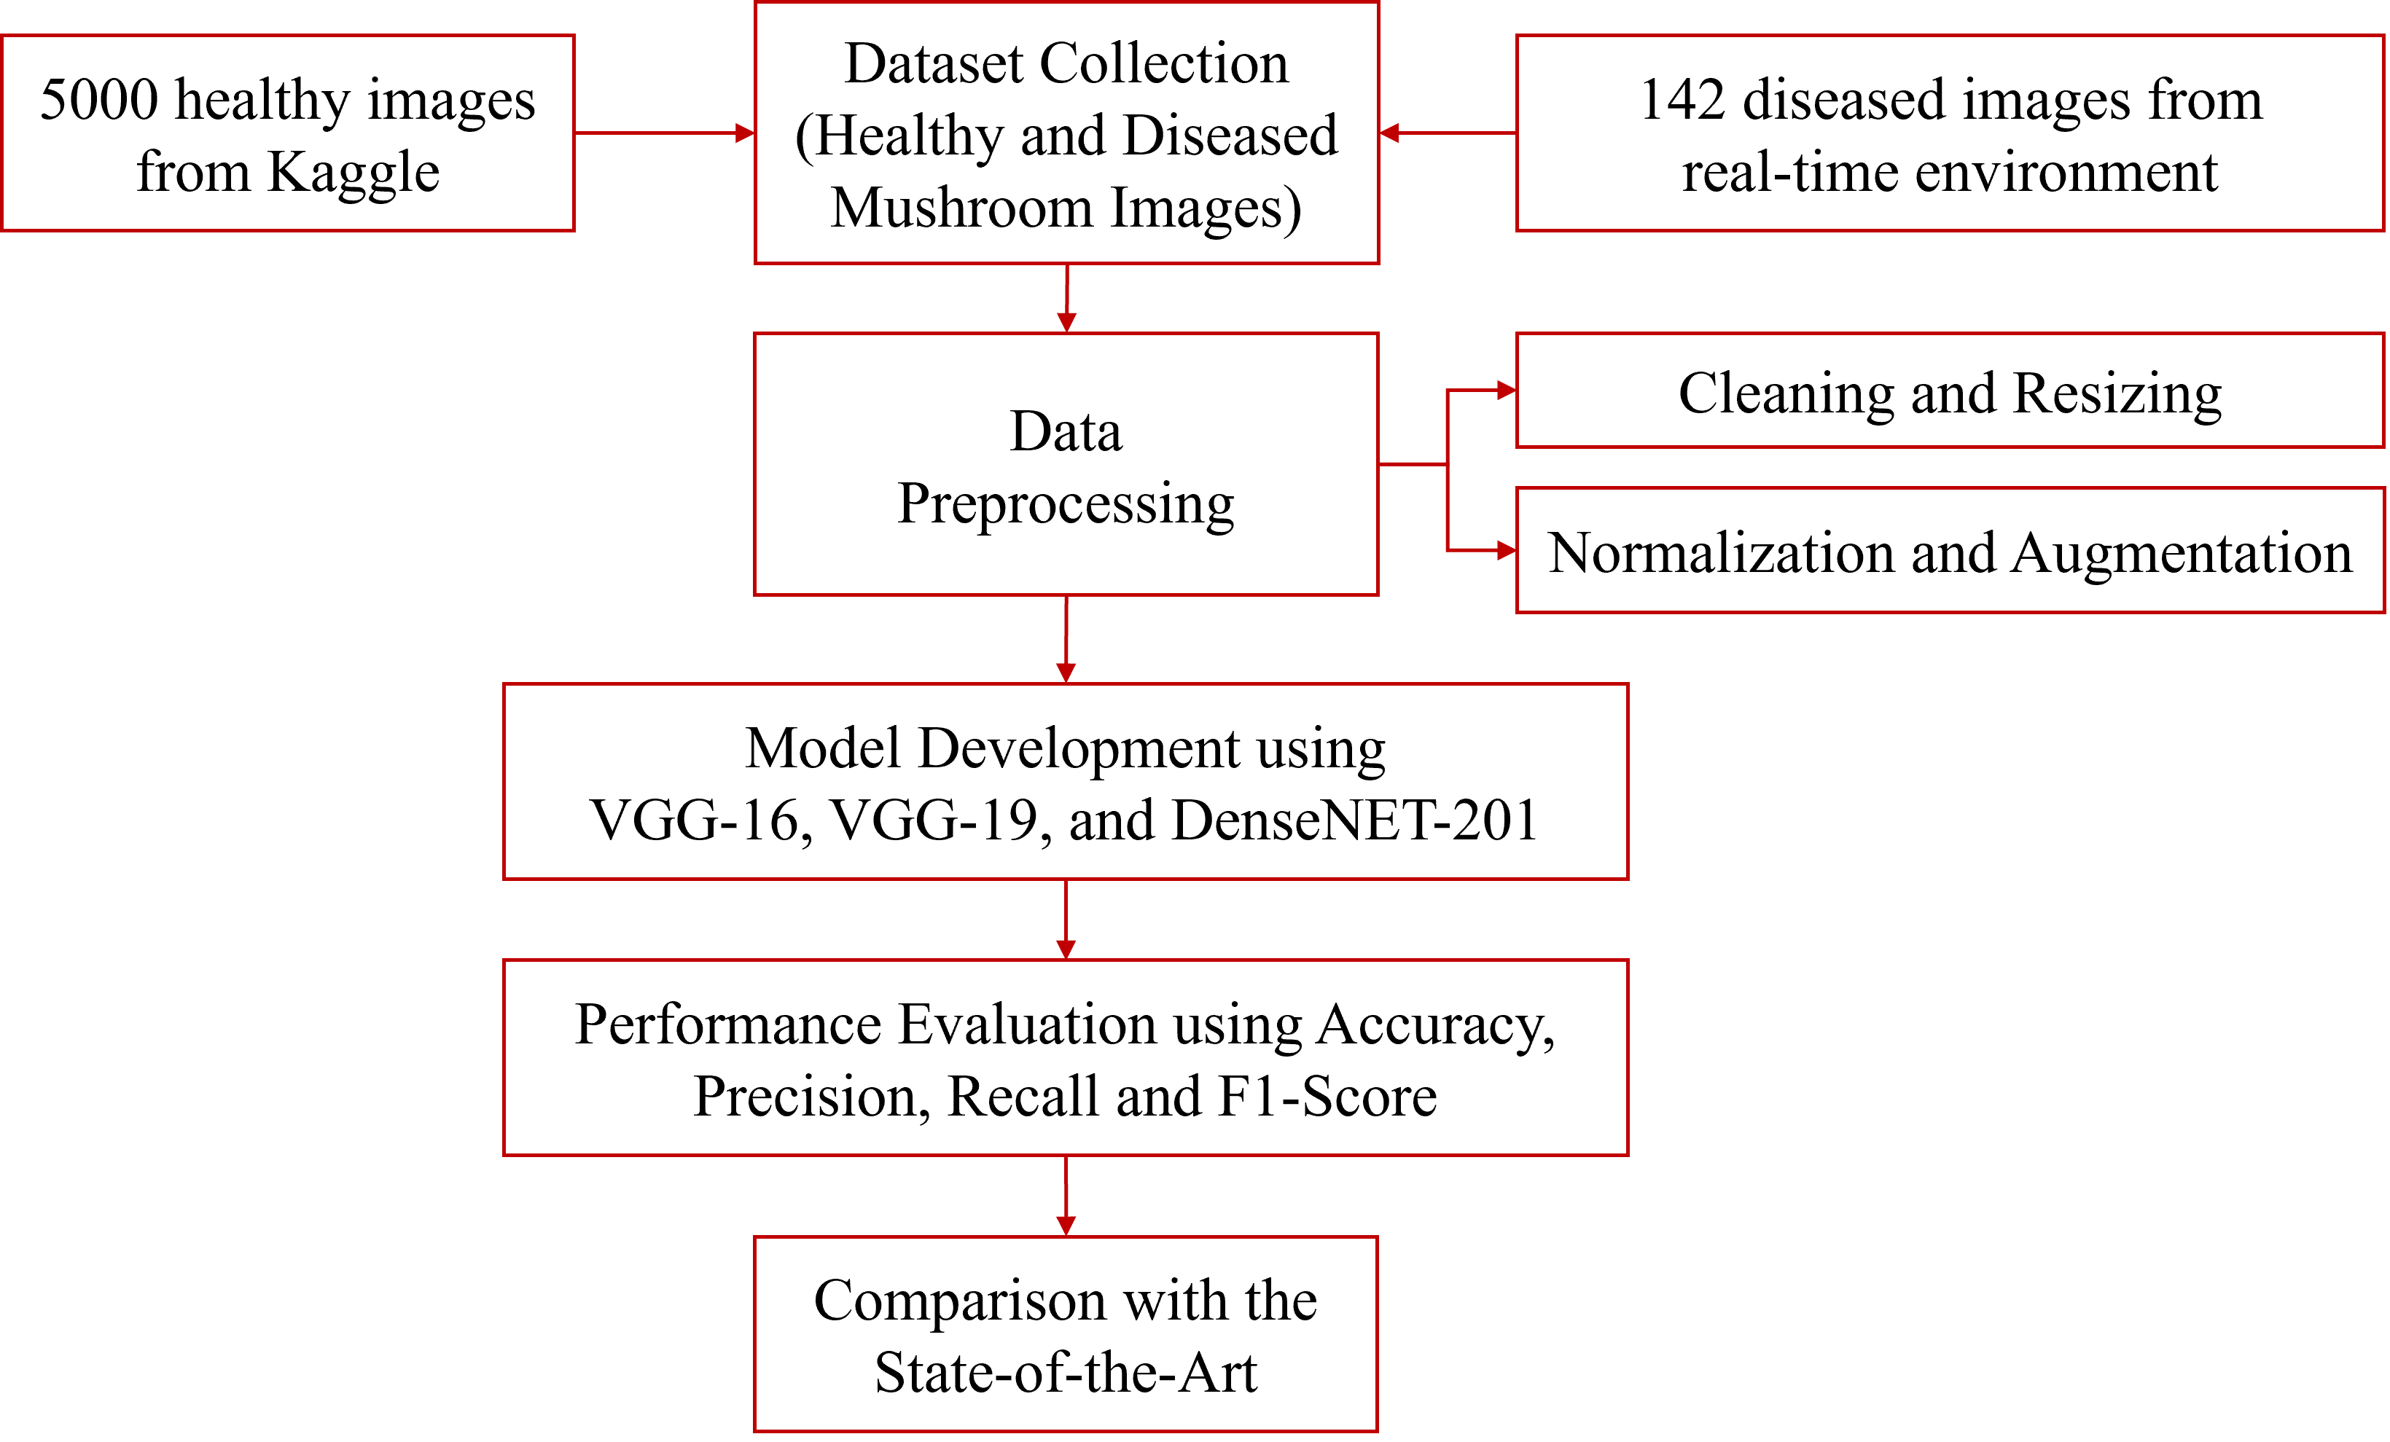
Figure 5. Methodology Adopted for Disease Detection in Mushrooms

  - Data Collection
From the extensive literature studies, it has been found that various researchers have used different datasets from different sources for conducting studies on mushrooms and their disease classifications. Table 5 is a tabular representation of the various sources and datasets used in the previous studies.
Table 5: Comparison of Mushroom Classification Dataset
Dataset Name | Description | Size | Algorithms | Evaluation Metrics | Source
Mushroom  Classification [36] | 23 species of gilled mushrooms  Edible, poisonous  And North American Mushrooms | 8124  instances and 22 features | K-means Bagging, Gradient Boosting, Adaboost XG Boost | Highest Accuracy achieved (KNN) =99%, | UCI  Machine Learning Repository
Mushrooms classification - Common genus's images [32] | 9 distinct species of mushrooms  And Northern European mushrooms | 6714  Images | VGG-16, RessNet-34  Inception-V3, Inception-ResNet-V2, Xception | Accuracy | Kaggle
12 Mushroom Species Dataset [37] | 11 distinct species of mushrooms | 9528  Images | Inception-V3, Xception ViT-L/32, VGG-16, Inception-ResNet-V2, ResNet-34. | Highest Accuracy achieved ViT-L/32) =95, | (Mushroom World) Kaggle
Edible and Poisonous Fungi [30] | Mushroom edible and poisonous sporocarps | 3401  Images | XBOOST,Randam Forest,CNN | Highest Accuracy achieved by CNN = 64% | Kaggle

The dataset used consists of a total of 5142 images, out of which 142 images are of diseased mushrooms and 5000 are healthy mushrooms. The diseased images are collected from real-time sources, ensuring authentic and expert-verified samples, and the remaining 5000 images are sourced from the Kaggle repository, which contains 12 species of mushrooms, out of which this study is using 5 edible species (Agaricus, Boletus, Pluteus, Suillus, and Lactarius).
Two cases are considered in this study. In the first case, 5142 original images are used without augmentation, and in the second case, 142 diseased images are expanded to 2080 images by applying image augmentation, summing up to 7080 images. In response to RQ 1, augmentation methods like rotation, horizontal flipping, vertical flipping, zoom cropping, and brightness, are used to produce an augmented dataset that helps to overcome over-fitting and class imbalance problems.
Data Preprocessing
To ensure compatibility with standard DL architectures and improve training efficiency, several preprocessing steps were applied to the dataset. All input images were resized to 224 × 224 pixels, which was then aligned with the input constraints of VGGNet16, VGGNet19, and DesNet201. Resizing followed by normalization of pixel values helps standardize the input shape and retain adequate detail for accurate feature extraction. Alter the original pixel values (0 to 255), were normalized to the range [0, 1], which helps in stabilizing and accelerating the training process. Table 6 represents the images after 7 different augmentations when applied on inky cap disease image.
Table 6: Different Augmentation Techniques
Original Image | Augmentation Type | Description | Example Parameter / Method | After Augmentation
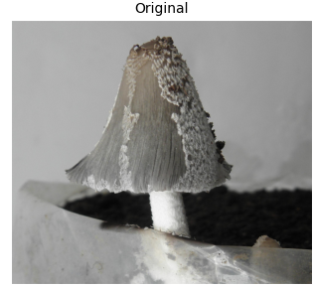 | Rotation | Rotates the input image by a random degree within a specified range to simulate orientation variation. | rotation_range = 40 | 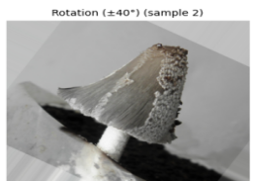
 | Horizontal Flip | Flips the image horizontally, creating a mirror reflection to improve left–right invariance. | horizontal_flip = True | 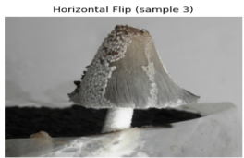
 | Vertical Flip | Flips the image vertically to create top–bottom inversions, enhancing spatial diversity. | vertical_flip = True | 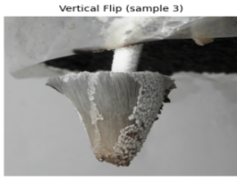
 | Zoom | Randomly zooms in or out within a defined scale range, enabling the model to handle variations in object size. | zoom_range = [0.8, 1.2] | 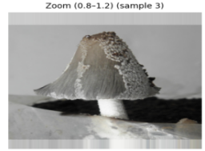
 | Cropping | Randomly crops portions of the image to focus on sub-regions and improve localization robustness. | tf.image.random_crop() or manual cropping | 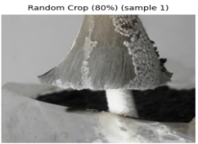
 | Width Shift | Translates the image horizontally to the left or right by a fraction of the total width. | width_shift_range = 0.2 | 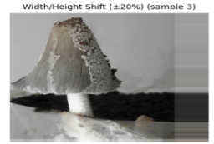
 | Brightness Adjustment | Randomly adjusts image brightness to handle illumination changes during image acquisition. | brightness_range = [0.5, 1.5] | 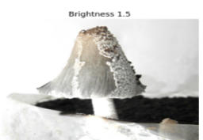

- Results and Discussion
This study aims to examine the results of mushroom classification and classify it into healthy or diseased mushrooms utilizing the three most popular DL techniques. Initially, different methods of image preprocessing were applied to prepare the images for feeding into the deep learning architecture. Subsequently, the DL approach has been applied for classifying the healthy and diseased mushroom types. Two experimental cases have been implemented in this study. The first case is conducted using un-augmented images, whereas the second case involves the augmentation of images on which the VGG16, VGG19, and DenseNet201 models are implemented.
The development of the entire training and testing of the mushroom-type classification model was done using Jupyter on a local server. Tesla T4 was defined as the graphics processing unit, and 16 GB was used for training and testing, and an 11th Gen Intel (R) Core (TM) i5 processor is used. Convolutional layer is commonly used in all kinds of deep neural network architectures for feature extraction of images, and the maxpool layer is applied for reducing the dimension of the matrix. DesNet 201 outperforms the other two models.

  - CASE 1: Without Augmentation

The total dataset in the first case used images in the experiment for mushrooms is 5142, out of which 142 images are of diseased mushrooms, and 5000 are healthy mushrooms. These are split into two different ratios and used to study two different scenarios. Table 8 demonstrates a tabular depiction of the distribution of the dataset images in both scenarios of the study.
Table 8: Two Scenarios of Image Distribution in Case 1
Total images – 5142 (diseased images – 142; non-diseased images – 5000) | Split Ratio
 | 80:20 | 70:30
Training Images | 4113 | 3599
Testing Images | 1029 | 1543
In the first scenario, the dataset was split in an 80:20 ratio. There was a total of 4113 image data points that were used for training purposes, wherein 4113 is 80% of the total number of image data points. The remaining 20% of the images, i.e., 1029 images, are used for testing purposes. The deep neural network performance is inspected by the performance matrices, and a comparative analysis is presented among the DL architectures used.
In the second scenario, the dataset was split into a 70:30 ratio. 70% of the image data came up to 3599 images, which were used for training purposes, and the rest 30% of the dataset comprised 1543 images, which were used for testing purposes.
Confusion matrices:
Confusion matrices for all evaluated CNN models clearly illustrate their classification performance in the two categories: Diseased and Healthy. Figure 9 (a) shows the confusion matrix of VGG16 trained with an 80:20 train-test split, demonstrating good classification accuracy. 992 cases were correctly classified, with only 1 misclassified as diseased. For the disease category, 7 out of 36 samples were correctly identified, while 29 were misclassified as healthy. Although the model shows excellent performance in detecting healthy cases, the sensitivity toward diseased samples is relatively lower. Figure 9 (b) represents the VGG16 model with a 70:30 split. In this case, all 1497 healthy samples were correctly identified with zero misclassifications. However, for diseased cases, only 4 out of 46 were correctly detected, and 42 were misclassified as healthy, indicating a drop in disease detection capability despite perfect healthy classification. Figure 9 (c) depicts the VGG19 model trained with an 80:20 split, achieving a balanced classification. 993 healthy samples were correctly predicted, and for diseased samples, 34 out of 36 were correctly classified, with only 2 being misclassified. This indicates both high sensitivity and specificity.
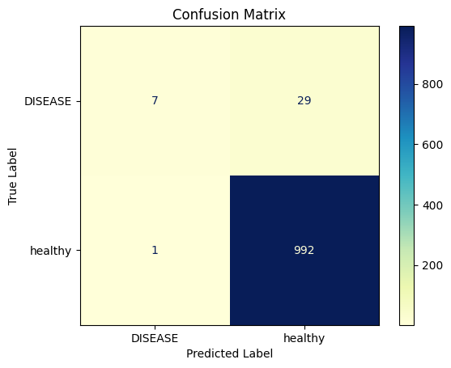 | 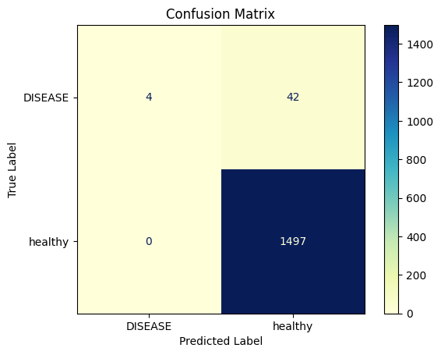
(a) | (b)
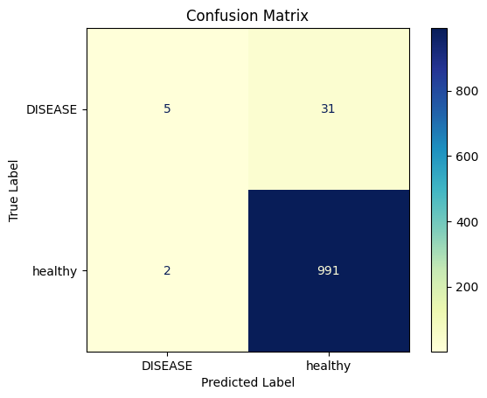 | 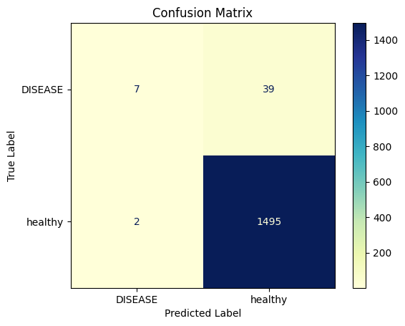
(c) | (d)
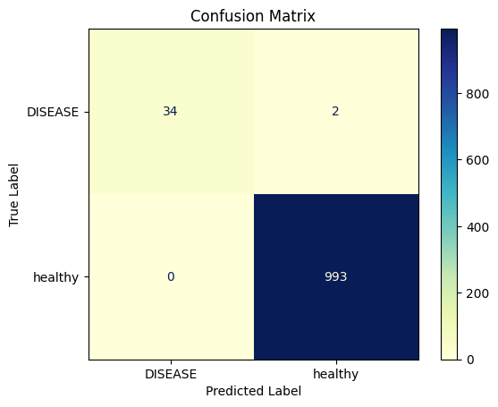 | 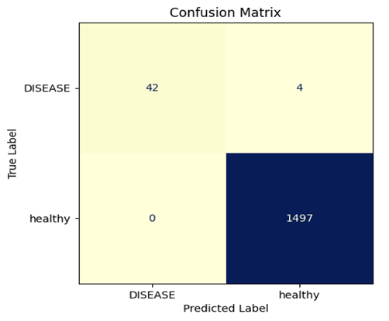
(e) | (f)
Figure 9: Confusion Matrices for Evaluated CNN Models (a) VGG 16 (80:20); (b) VGG 16 (70:30); (c) VGG 19 (80:20); (d)VGG 19(70:30); (e) DesNet 201 (80:20); (f) DesNet 201(70:30)
Figure 9 (d) shows VGG19 with a 70:30 split, yielding perfect classification for healthy cases (1497 correctly identified) and high accuracy for diseased cases, with 42 out of 46 correctly predicted and only 4 misclassified. Figure 9 (e) illustrates that the DenseNet201 model using an 80:20 split achieves near-perfect classification with minimal misclassifications. All 993 healthy samples were classified correctly, and for diseased cases, 42 out of 46 were correctly detected with only 4 misclassifications, showcasing strong robustness. Figure 9 (f) represents DenseNet201 with a 70:30 split, achieving the highest performance among the evaluated models. The model correctly classified all 1497 healthy samples and identified all 46 diseased cases without any misclassification, reflecting perfect sensitivity and specificity.

Performance Metrics:
The performance of the evaluated CNNs’ three pretrained architectures before augmentation in response to RQ3 is summarized in Table 9. Among the 3 architectures assessed, DenseNet201achieved the highest overall score of 99.81%. For VGG16, the 80:20 split achieved an accuracy of 97.08%, with a relatively high precision (88.00%) but considerably lower recall (19.00%) and F1-score (32.00%). When using the 70:30 split, accuracy slightly improved to 97.28%, and precision reached the maximum possible value (100.00%), though recall dropped further to 9.00%, resulting in an F1-score of 16.00%.
Table 9. Performances Metrics for VGG16, VGG19, and DenseNet201 (80:20 and 70:30 Splits)
Model | Split | Accuracy (%) | Precision (%) | Recall (%) | F1-Score (%)
VGG-16 | 80:20 | 97.08 | 88.00 | 19.00 | 32.00
 | 70:30 | 97.28 | 100.00 | 9.00 | 16.00
VGG-19 | 80:20 | 96.79 | 84.00 | 57 | 61
 | 70:30 | 97.34 | 78.00 | 15.00 | 25.00
DenseNet-201 | 80:20 | 99.81 | 100.00 | 94.00 | 97.00
 | 70:30 | 99.74 | 100.00 | 91.00 | 95.00

For VGG19, the 80:20 split yielded an accuracy of 96.79%, with balanced precision (84.00%) and recall (57.00%), resulting in an F1-score of 61.00%. In contrast, the 70:30 split improved accuracy to 97.34%, but precision decreased to 78.00%, recall dropped significantly to 15.00%, and F1-score declined to 25.00%.
In response to RQ. 4, it can be stated that DenseNet201, both splits, demonstrated superior overall performance compared to VGG variants. The 80:20 split achieved the highest accuracy (99.81%), perfect precision (100.00%), high recall (94.00%), and an F1-score of 97.00%. Similarly, the 70:30 split recorded an accuracy of 99.74%, with precision remaining at 100.00%, recall at 91.00%, and F1-score at 95.00%. Thus, DenseNet201 consistently showed better outperformance than VGG16 and VGG19 across both split ratios, especially in terms of recall and F1-score, indicating its robustness and better generalizability for the given dataset.
Performance Analysis Curves:
Figure 10 demonstrates a comprehensive performance comparison of VGG16, VGG19, and DenseNet201 on training and validation losses, training and validation accuracies over 10 epochs. These metrics reflect each model’s learning behavior, generalizability, and convergence efficiency during training for mushroom disease classification in the 70:30 ratio split.
In training loss of VGG16, VGG19, and DenseNet201, DenseNet201 achieves the lowest training loss, which reduces steeply in the first two epochs, whereas VGG19 and VGG16 converge and stabilize more slowly. DenseNet201 shows a steep rise in training accuracy of < 98% by epoch-3 and stabilizes close to 100%, whereas VGG19 and VGG16 converge slower reaching near 97%. DenseNet201 maintains higher validation accuracy near to 100% after the epoch 4, while VGG19 remains steady at 97% and VGG16 shows little improvement from 96% to 97%. DenseNet201 outperforms the VGG16 and VGG19, decreasing validation loss < 0.01.
These results show DenseNet201’s superior convergence speed and generalization capability, likely attributed to its dense connectivity pattern, which facilitates enhanced gradient flow and feature reuse, resulting in both lower loss and higher accuracy during training and validation phases.
The comparative analysis of VGG16, VGG19, and DenseNet201 models reveals significant differences in their training and validation performance when verified at the 80:20 split scenario. As shown in Figures 10 and 11, DenseNet201 consistently outperforms both VGG architectures in terms of faster convergence, lower training and validation losses, and higher validation accuracy across epochs. While VGG16 and VGG19 achieve stable performance after the initial epochs, they exhibit relatively higher loss values, indicating slower optimization. DenseNet201, on the other hand, demonstrates superior generalization with minimal overfitting, as evidenced by its steep decline in loss and rapid improvement in accuracy. These results suggest that DenseNet201 is a more efficient and robust architecture for the given dataset, achieving better trade-offs between accuracy and loss when compared to the deeper but less efficient VGG models.

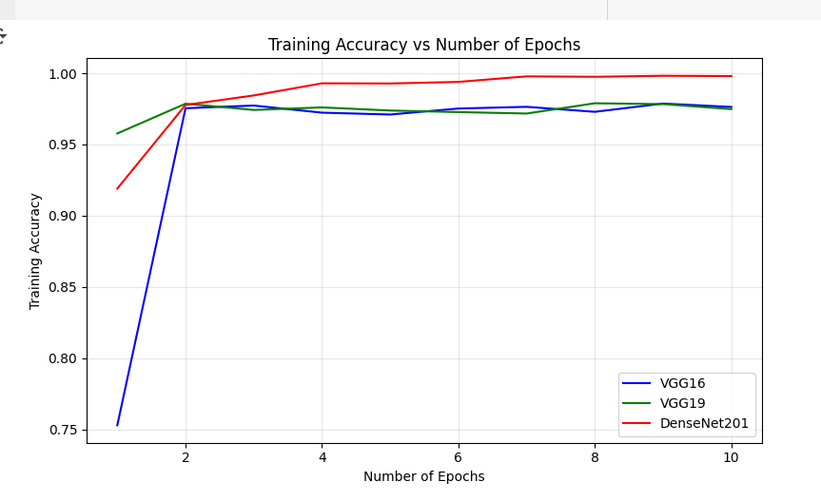 | 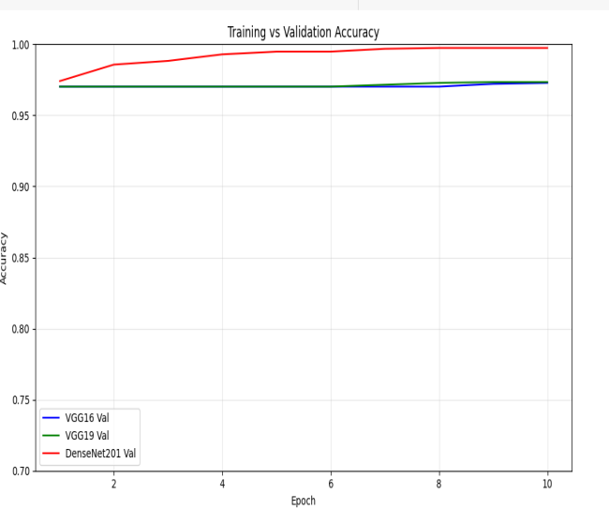
(a) | (b)
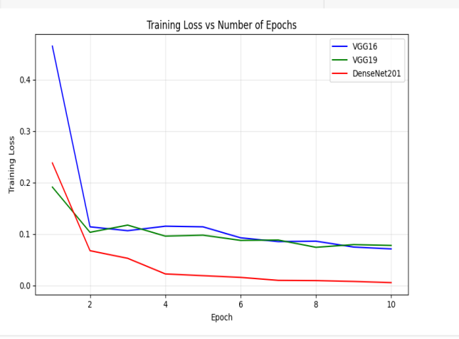 | 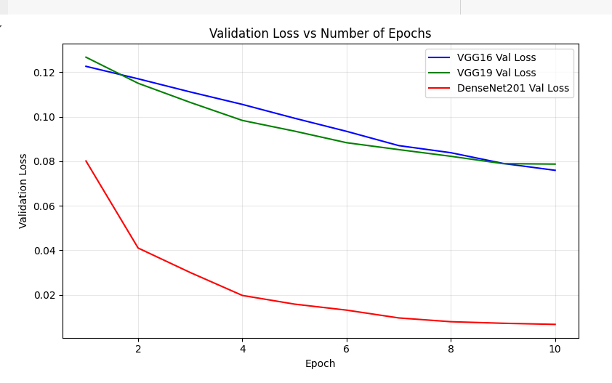
(c) | (d)
Figure 10. Training and Validation Curves for Evaluated CNN Models 70:30 split (a)Training Accuracy of VGG16, VGG19, and Densenet201; (b) Validation Accuracy of VGG16, VGG19, and Densenet201; (c) Training Loss of VGG16, VGG19; (d) Validation Loss of VGG16, VGG19, and Densenet201

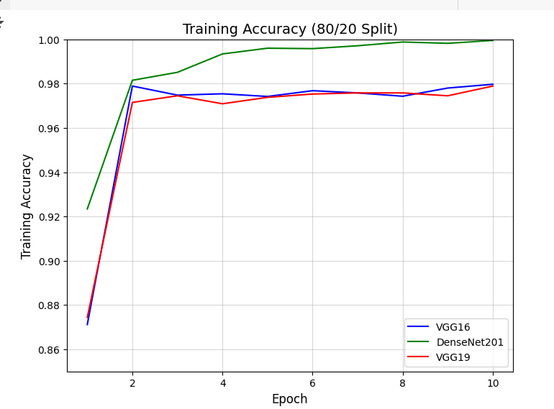 | 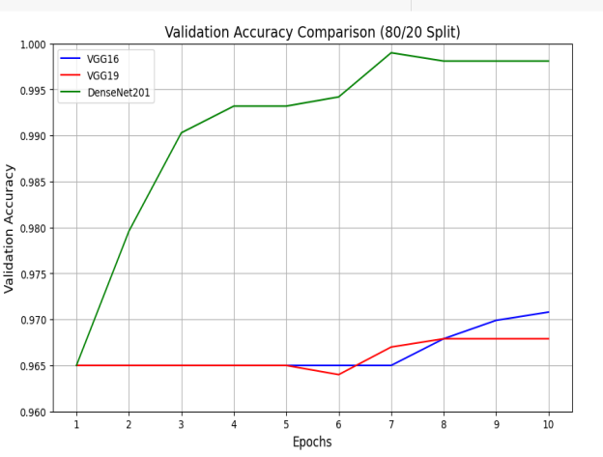
(a) | (b)
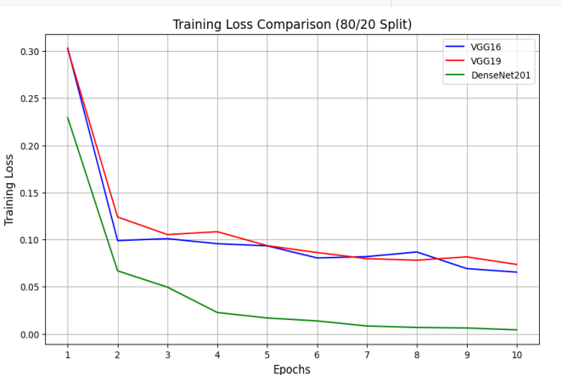 | 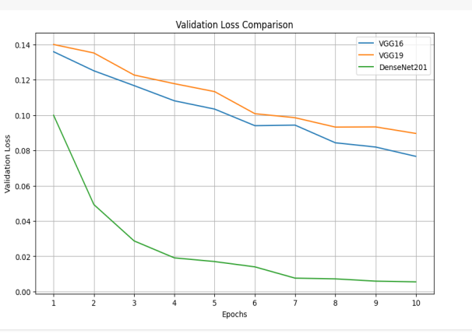
(c) | (d)
Figure 11. Training and Validation Curves for Evaluated CNN Models 80:20 split (a)Training Accuracy of VGG16, VGG19, and Densenet201; (b) Validation Accuracy of VGG16, VGG19 and Densenet201; (c) Training Loss of VGG16, VGG19; (d) Validation Loss Accuracy of VGG16, VGG19, and Densenet201

  - CASE 2: With Augmentation
The total dataset in the first case used images in the experiment for mushrooms is 7080, out of which 2080 images are of diseased mushrooms, and 5000 are healthy mushrooms. These are split into two different ratios and used to study two different scenarios. Table 10 demonstrates a tabular depiction of the distribution of the dataset images in both scenarios of the study.
Table 10: Two Scenarios of Image Distribution in Case 2
Total images – 7080 (diseased images – 2080; non-diseased images – 5000) | Split Ratio
 | 80:20 | 70:30
Training Images | 5664 | 4956
Testing Images | 1416 | 2124
The techniques applied for augmentation are Rotation, Horizontal Flipping, Vertical flipping, Zoom, Cropping, Width Shift, and Brightness.
After applying the image augmentation over the diseased images total number of diseased images is 2000 because the dataset of diseased images was smaller before, and the dataset of healthy and diseased mushroom were imbalanced. The total number of mushroom images used in the experiment dataset are 7080, out of which 2080 are images of diseased mushrooms and 5000 are healthy mushrooms. There is a total of 5664 image data for training, which is 80% of the total number of image data, and 1416 images are used for testing purposes. After a 70:30 split, 4956 total image data were used for training purposes, which is 70% of the total data images, and 2124 images were used for testing purposes.

Confusion matrices:
To evaluate the performance of the VGG16 and VGG19 models on the mushroom disease classification task, confusion matrices were constructed under two different data split scenarios: 80:20 and 70:30. These matrices provide insight into the models' prediction accuracy for the two classes, healthy and diseased.
Figure 12 (a) illustrates the VGG16 (80:20) model correctly classified 406 disease cases and 1002 healthy cases, with only a few misclassifications, indicating high sensitivity and specificity. Figure 12 (b) depicts the VGG16 (70:30) model classified with 609 true positives for disease and 1509 true negatives for health, showing robustness with minimal errors in the case of a 70:30 split. Figure 12 (c) represents the VGG19 (80:20) model, which detected 405 disease cases and 1004 healthy cases, showing competitive accuracy with slightly fewer errors than VGG16. Figure 12 (d) shows the VGG19 (70:30) model correctly identified 608 healthy and 1505 diseased samples, with a misclassification of 1 sample, respectively. This still indicates excellent generalization, comparable to the 80:20 case.
Figure 12 (e) illustrate DesNet201(80:20) model made one false positive prediction, in which a healthy individual was incorrectly classified as diseased, and two false negative predictions, where diseased crops were mistakenly classified as healthy. Figure 12(f) illustrates, under the 70:30 training-testing split, DenseNet201 still retained a high accuracy, correctly identifying 609 disease cases and 1510 healthy cases, maintaining balanced performance across both classes.

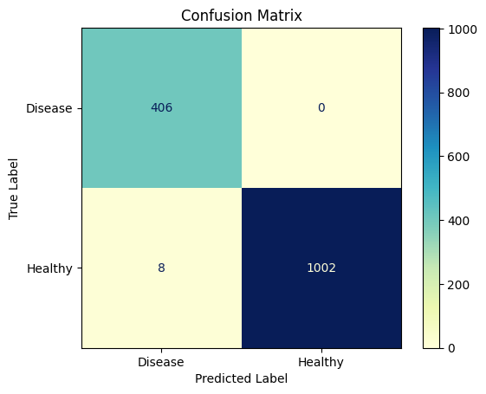 | 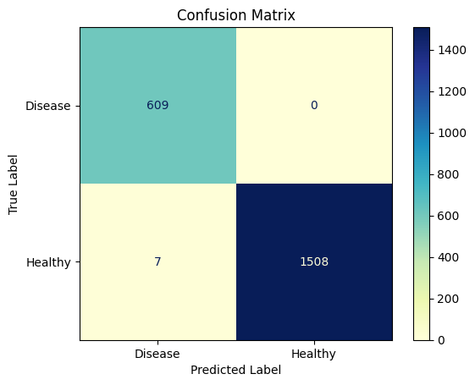
(a) | (b)
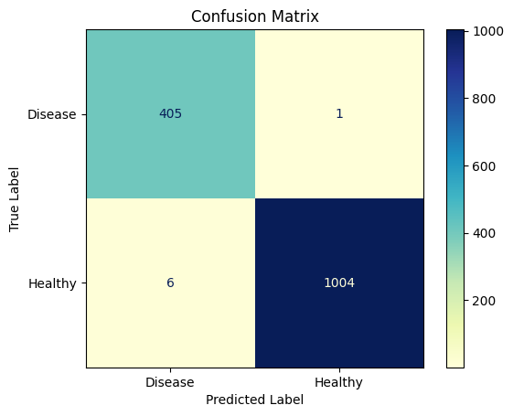 | 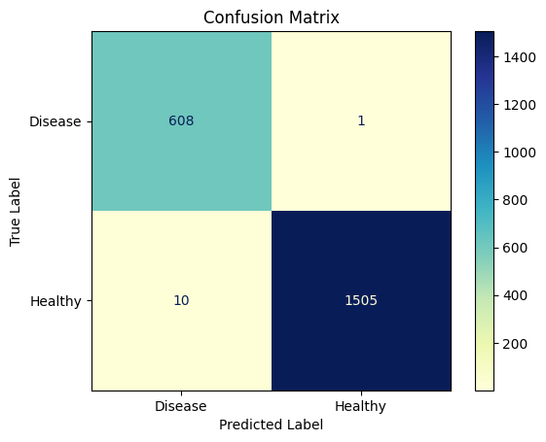
(c) | (d)
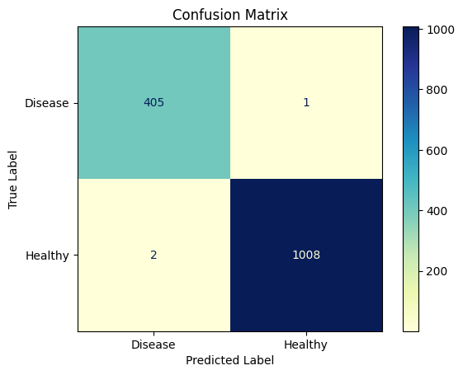 | 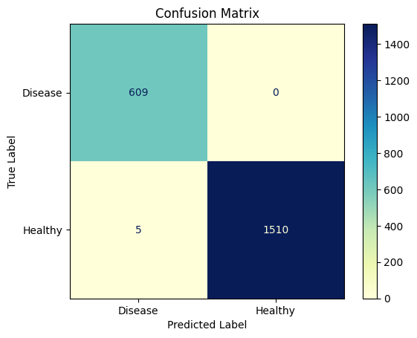
(e) | (f)
Figure 12: Confusion Matrices for Evaluated CNN Models after augmentation (a) VGG 16(80:20); (b) VGG 16(70:30); (c)VGG 19(80:20); (d)VGG 19(70:30); (e) DesNet 201(80:20); (f) DesNet 201 (70:30) VGG16 (80:20 split)

Performance Metrics:
Table 11 summarizes the performance of three pre-trained CNN architectures, such as VGG16, VGG19, and DenseNet20, evaluated on augmented mushroom disease image datasets in response to RQ3 key evaluation metrics include accuracy, precision, recall, F1-score, and Average Precision (AP). The results clearly highlight the effectiveness of transfer learning and image augmentation in improving classification accuracy.

Table 11. Performances Metrics for VGG16, VGG19, and DenseNet201 (80:20 and 70:30 Splits) after augmentation
Model | Split | Accuracy (%) | Precision (%) | Recall (%) | F1-Score (%) | MA (Macro Average) (%)
VGG-16 | 80:20 | 99.44 | 98.00 | 1.00 | 99.00 | 99.00
 | 70:30 | 99.67 | 99.00 | 1.00 | 99.00 | 99.00
VGG-19 | 80:20 | 99.51 | 99.00 | 1.00 | 99.00 | 99.00
 | 70:30 | 99.48 | 98.00 | 1.00 | 99.00 | 99.00
DenseNet-201 | 80:20 | 99.79 | 1.00 | 1.00 | 1.00 | 1.00
 | 70:30 | 99.76 | 99.00 | 1.00 | 1.00 | 1.00

VGG16 with 80:20 train: test split scored an accuracy of 99.44%, with precision, recall, and F1-score of 99%. This shows a strong classification performance, but a little slower than VGG19 and DenseNet201. VGG16 with a 70:30 train: test split showed an improvement in accuracy of 99.67%. Precision, F1-score, and macro average all reached 99%, indicating robust generalization ability and the effectiveness of augmentation in reducing overfitting. VGG19 with 80:20 train: test split resulted in improved performance, yielding an accuracy of 99.51%, with precision, recall, and F1-score all at 99%. The greater depth enabled enhanced feature abstraction, and in combination with augmentation, the model demonstrated high classification reliability. Under the 70:30 split, VGG19 achieved 99.48% accuracy, which is slightly higher than VGG16 but marginally lower than its 80:20 performance. Nevertheless, precision, recall, and F1-score consistently remained at 99%, confirming that the deeper network maintains high performance even with reduced training samples.
DenseNet201(80:20 Split) demonstrated a superior performance compared to both VGG models, attaining the maximum accuracy of 99.79% along with 100% precision, recall, and F1-score. This shows the advantage of dense skip connections in helping feature reuse and improving classification confidence. Even with a 70:30 Split larger test set, DenseNet201 maintained strong generalization, achieving 99.76% accuracy, with precision, recall, and F1-score at 100%. The marginal decrease in accuracy compared to the 80:20 split can be attributed to fewer training samples; however, its consistently perfect precision and recall highlight the robustness of the architecture. In response to RQ. 4, it can be stated that DenseNet201 outperformed both VGG16 and VGG19, achieving near-perfect classification with superior feature reuse and robustness.

Performance Analysis Curves
In case of a 70:30 split, the training loss of DenseNet201 has the fastest and smoothest convergence, rapidly reaching to the least loss caused by feature reuse. It keeps the lowest training loss throughout, showing a strong optimization and minimized overfitting. DenseNet201 always shows the lowest and most stable validation loss, showing an excellent generalization, VGG16 shows the maximum and most volatile loss, especially in the initial epochs.
In case of training accuracy, all models show fast and enhanced convergence within the first 5 epochs among which DenseNet201 being the fastest. DenseNet201 and VGG19 cross 99% accuracy and outperforms VGG16 and VGG19.

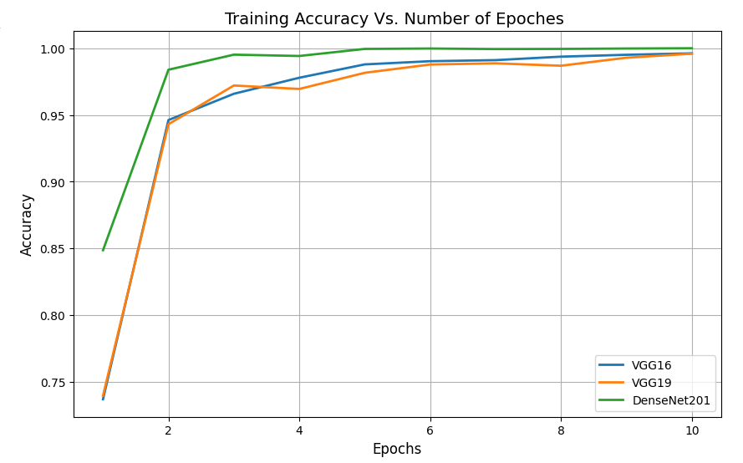 | 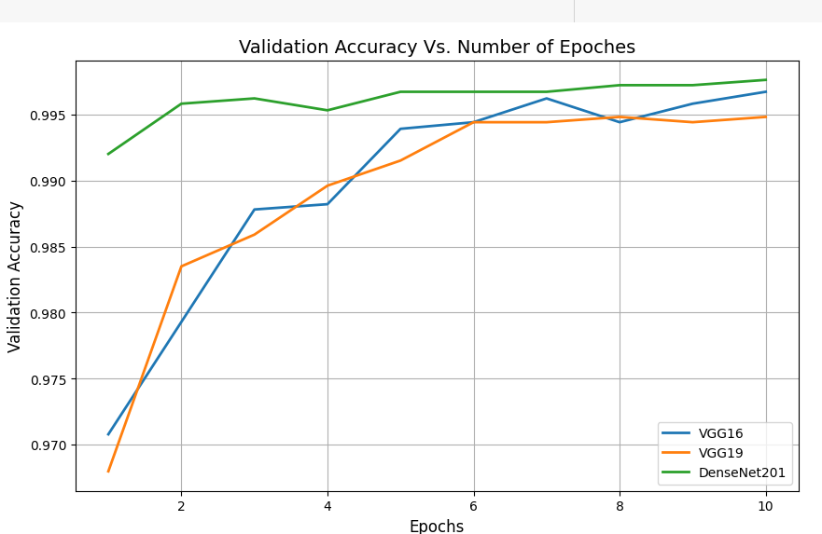
(a) | (b)
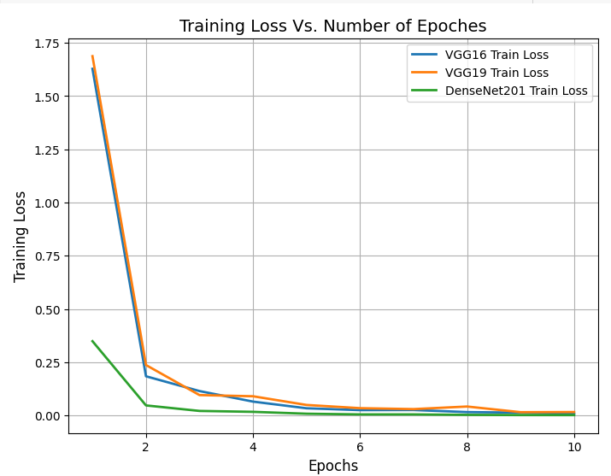 | 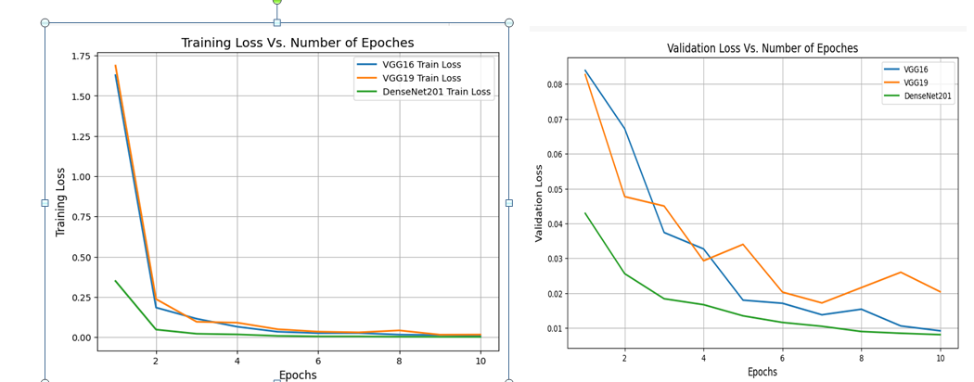
(c) | (d)
Figure 13. Training and Validation Curves for Evaluated CNN Models 70:30 split after augmentation (a)Training Accuracy of VGG16, VGG19, and Densenet201; (b) Validation Accuracy of VGG16, VGG19, and Densenet201; (c) Training Loss of VGG16, VGG19, and Densenet201; (d) Validation Loss of VGG16, VGG19, and Densenet201

To calculate the effect of image augmentation on the dynamics of model training, this section analyzes VGG16, VGG19, and DenseNet201, in terms of the training and validation curves at over 10 epochs in the 80:20 split ratio. The models were trained on augmented mushroom disease datasets where the metrics considered included training loss, validation loss, training accuracy, and validation accuracy.
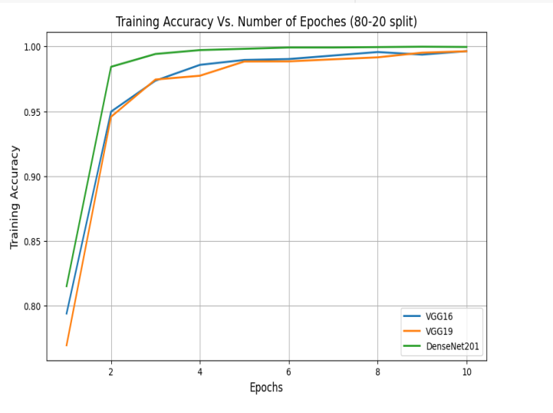 | 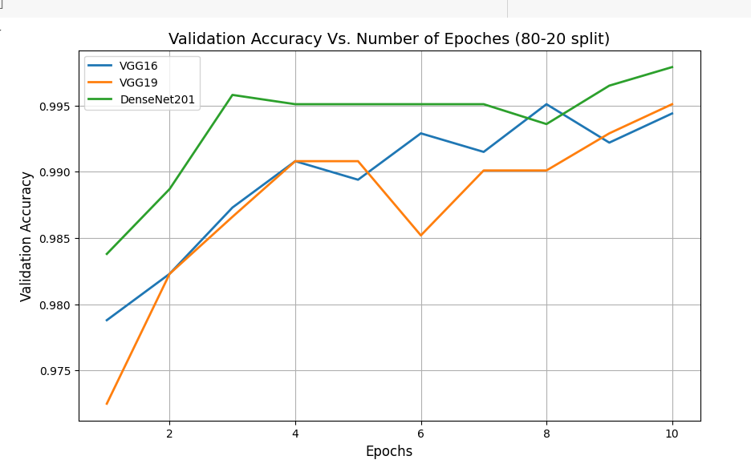
(a) | (b)
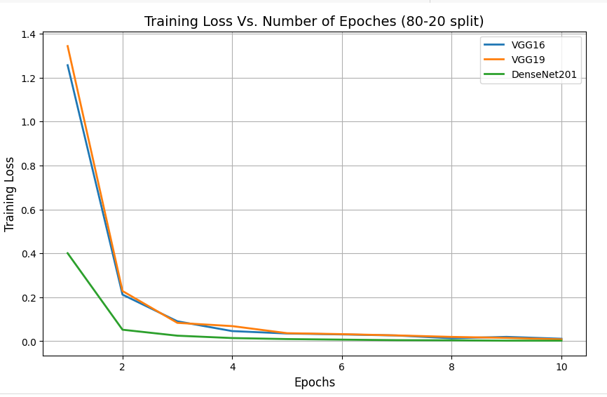 | 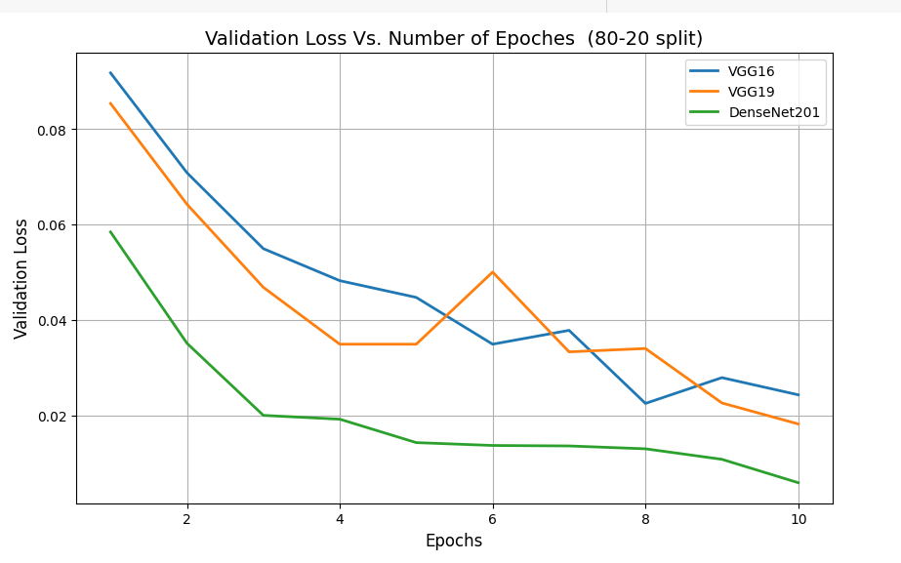
(c) | (d)

Figure 14. Training and Validation Curves for Evaluated CNN Models 80:20 split after augmentation (a)Training Accuracy of VGG16, VGG19 and Densenet201; (b) Validation Accuracy of VGG16, VGG19, and Densenet201; (c) Training Loss of VGG16, VGG19, and DenseNet201; (d) Validation Loss Accuracy of VGG16, VGG19, and Densenet201

The comparison and analysis of Figures 13 and 14 shows that DenseNet201 continuously attains better performance over VGG16 and VGG19 across training and validation. In both plots, DenseNet201 shows the fastest convergence with the lowest losses during training as well as validation, while maintaining the highest accuracy. Although VGG16 and VGG19 demonstrate competitive improvements, their curves show slower convergence and greater oscillations, particularly in validation accuracy.

Comparison with the present state of the art
Various approaches to disease detection in mushrooms have been used by researchers. A comparative analysis of few ML and DL patterns that are implemented in mushroom classification and disease detection is provided in Table 12. Transformer-based architectures were shown to be effective, as Vision Transformer (ViT-L/32) achieved a high accuracy of 95.97% in automatically classifying mushroom species [37].

Table 12: Comparison of Existing Study Approaches.
Approach | Methodology and Technologies | Accuracy
RF algorithm [23] | Classifiers are used in the process of categorization of different mushroom diseases. | 82%
ResNet15 [43] | Classified different mushroom disease with the disease features. | 90%
ViT-L/32 [37] | Capable of automatically classifying mushroom species. | 95.97%
VGG-19 and CNN [48] | A classifier used for recognizing fresh or decayed mushrooms. | 96.5%
SVM [50] | Classified based on the study of different environmental factors like temperature, humidity, etc. | 98.60%
DenseNet201 | A classifier used for classifying healthy and diseased mushrooms | 99.79%

The ResNet15 model achieved 90% accuracy using the disease-specific features [43], whereas RF attained moderate performance at 82% accuracy [23]. By using the environmental parameters, including temperature and humidity, the SVM was able to outperform a number of models with an accuracy of 98.6 %. On the same note, VGG-19 in combination with CNN specifications resulted in 96.5% accuracy in the detection of fresh and decaying mushrooms. Of all the methods, DenseNet201 was the most effective in terms of 99.79% accuracy, showing that it was more effective in reusing features and that it was more efficient in classification [48]. The authors of this study have come up with a DenseNet201 approach, which classified the healthy and diseased mushrooms with 99.79% accuracy.
Conclusion and Future Scope
Cultivation of mushrooms plays a pivotal role in agriculture, economy, and food production on a global scale, but its susceptibility to disease and its timely detection remain a prevailing threat, which makes it more essential to enhance food security. This study proposes a transfer learning-based DL framework for classification of the mushroom diseases using three pretrained CNN architectures: VGG16, VGG19, and DenseNet201.
A curated custom dataset comprising 5,142 images was implemented with two scenarios of 80:20 and 70:30 train–test split ratios by the three CNN models. In both scenarios of splits, the dataset images were not augmented. And in both scenarios, DenseNet201 continuously outperformed the VGG16 and VGG19 architectures by achieving the highest classification accuracies of 99.81% and 99.74% in 80:20 and 70:30 splits. It also produced 100% precision, 94% recall, and 97% F1-score. VGG16 and VGG19 depicted respective accuracies of more than 96%, while their recall values were as low as 9%, which indicated limited ability to detect diseased images.
To overcome the imbalance in the dataset and promote generalization, data augmentation techniques were used. This increased the dataset to 7,080 images (2,080 diseased and 5,000 healthy). All the models demonstrate enhanced performance in the case of an augmented dataset with diseased images. DenseNet201 achieved 99.79% and 99.76% accuracies for 80:20 and 70:30 splits, with the other performance metrics values approaching 100%. Improvements in performances of VGG16 and VGG19 also exceeded 99% accuracy in both splits. The training and validation curves demonstrate that DenseNet201 shows a stable and faster convergence, with validation loss <0.01, across 10 epochs, as compared to the VGG architectures.
In a nutshell, this study demonstrates that DenseNet201 is the best, most accurate, and reliable architecture for classifyin mushroom diseases among all other models. This also demonstrates strong ability to be deployed in modern mushroom farming systems, facilitating accurate and rapid disease detection. Such solutions can significantly enhance the productivity and profit of precision agriculture by improving mushroom yield, contributing toward sustainable smart farming practices, and reducing economic losses.
Despite the near-perfect classification performance obtained, several more opportunities exist for future enhancement of this work. The diversity of the dataset may be increased to accommodate more diseases and increase the scope of generalization. More advanced architectures like EfficientNet, ResNet, MobileNet, Vision Transformers (ViT), and hybrid CNN-attention models could further be used to check for their performances and improve the results. The best performing model obtained can be integrated with real-time IoT-based farming setups and their mobile applications for further enhanced applicability and usability of the system in real-time, under varying environmental and other cultivation conditions.

